**Waste Management System Using Wireless Sensor Networks**

Fitzgerald Migire Omondi

112375

A Telecommunications Project II submitted to the School of Computing and Engineering Sciences (SCES) in Partial Fulfillment of the Requirements for the Bachelor of science in Telecommunications at

Strathmore University

January 2023

# Declaration

I declare that this work has not been previously submitted and approved for the award of a degree by Strathmore University or any other University. To the best of my knowledge and belief, the document contains no material previously published or written by another person except where due reference is made in the document itself.

Name: Fitzgerald Migire Omondi

Date: 06/01/2023

Signature: ***F.M.O***

Approval

The Telecommunications Media Project II of Fitzgerald Migire Omondi was reviewed and approved (for examination) by:

Name: Bruce Totona

Date: 06/01/2023

# Abstract

Environmental conservation has been a major concern for countries worldwide. One of the ways in which we manage our environment is by managing our waste effectively. Most developing countries have a system in place to help manage waste and most of the time it is not a centralized system which is highly dependent on how much people pay and waste is collected on specific days of the week. With the rapid expansion of technology, most major cities receive city-wide Wi-Fi connectivity. The current system of waste collection will always have some areas that will have instances of over-dumping. This however is not a real representation of how waste is disposed of within the city. Places with dense populations will tend to have overflowing dumpsters and require constant attention while sparsely populated areas will require less attention in terms of waste disposal. The project aims to automate and make the process of waste collection efficient by using wireless sensor networks and therefore leading to better waste management in the country. I have used a combination of sensors and network access networks to make this possible. This will help in keeping our cities and neighborhoods clean.

Contents

Declaration i

Abstract ii

List of Figures vi

CHAPTER 1: INTRODUCTION 1

1.1: Background 1

1.2: Problem Statement 2

1.3: Aim 3

1.4: Specific Objectives 3

1.5: Justification 3

1.6: Scope 3

1.7: Limitations 4

CHAPTER 2: LITERATURE REVIEW 5

2.1: Introduction 5

2.2: Technologies used in waste management 5

2.2.1: Artificial Intelligence 5

2.2.2: Wireless sensor networks 6

2.3: Wi-Fi Networks in waste management 6

2.4: Existing systems for waste management 7

2.4.1: Smart waste bins 7

2.4.2: Waste level sensors 7

2.4.3: Manual waste collection in Nairobi 8

2.5: Conceptual Framework 9

CHAPTER 3: METHODOLOGY 10

3.1: Introduction 10

3.2: System Development methodology 10

3.3: Project Design Approach 10

3.3.1: Requirements gathering and analysis 10

3.3.2: Design 11

3.3.3 Build, Evaluate, Refine and Implement the Prototype 11

3.3.4: Testing 11

3.4: Functional and Nonfunctional requirements 11

3.5: Tools and techniques 12

3.6: Deliverables 14

CHAPTER 4: SYSTEM ANALYSIS AND DESIGN 15

4.1: Introduction 15

4.2: System Architecture 15

4.3: Software Implementation 17

4.3.1: Arduino IDE 17

4.3.2: Firebase 23

4.3.3: Website 24

4.4.: Hardware Implementation 25

4.4.1: Dustbin Prototype 25

CHAPTER 5: TESTING, RESULTS AND DISCUSSION 29

5.1: Introduction 29

5.2: Testing 29

5.2.1: NodeMCU connection 29

5.2.2: Firebase and Website functionality 29

5.3: Test Cases 33

5.4: Conclusion 35

CHAPTER 6: CONCLUSION AND RECOMMENDATIONS 36

6.1: Conclusion 36

6.2: Recommendations 36

6.3: Future Works 36

REFERENCES 37

APPENDIX A: Gantt Chart 39

# List of Figures

Figure 1.1: Dumped waste in Nairobi CBD 2

Figure 2.1: Conceptual Framework 9

Figure 3.1: Incremental Prototyping model(Martin, 2022) 10

Figure 3.2: Ultrasonic sensor 12

Figure 3.3: ESP8266 Microcontroller 12

Figure 3.4: Jumper Cables 13

Figure 3.5 Bread Board 13

Figure 3.6: Arduino IDE 14

Figure 4.1: System Architecture 15

Figure 4.2: System Flow chart Diagram 1 16

Figure 4.3: System Flow Chart Diagram 2 17

Figure 4.4: ESP8266 setup 18

Figure 4.5: ESP8266 Library Setup 18

Figure 4.6: Adding required libraries 19

Figure 4.7: Inclusion of Wi-Fi and firebase credentials 19

Figure 4.8: Initialization of Firebase objects and pin definition 20

Figure 4.9: Connecting to the Wi-Fi network 20

Figure 4.10: Connection to firebase 21

Figure 4.11: Measuring of bin levels 21

Figure 4.12: Sending bin level data to firebase 22

Figure 4.13: Sending location data to firebase 22

Figure 4.14: Sending bin ID to Firebase 22

Figure 4.15: Real time database rules 23

Figure 4.16: Firebase authentication 23

Figure 4.17: Realtime database data and paths 24

Figure 4.18: Website landing page 24

Figure 4.19: JavaScript Firebase connection 25

Figure 4.20: Schematic diagram 26

Figure 4.21: Prototype connection to the top of the mock dustbin 27

Figure 4.22: Mock dustbin 28

Figure 5.1: Connection to Wi-Fi and data sending 29

Figure 5.2: Empty dustbin database levels 30

Figure 5.3: Empty Dustbin monitoring on website 30

Figure 5.4: Dustbin level below midpoint output on website 31

Figure 5.5: Dustbin level at midpoint output on website 31

Figure 5.6: Dustbin level above midpoint output on website 32

Figure 5.7: Full dustbin database levels 32

Figure 5.8: Dustbin level when full output on website 32

Figure 5.9: Alert when dustbin is full with location details 33

# CHAPTER 1: INTRODUCTION

## 1.1: Background

As the population of Nairobi grows, so does the amount of solid waste. According to Nairobi City County Office, Currently, the population of the city stands at approximately 5 million, with each individual generating about 0.62 kgs of garbage per day. By the year 2030, we will be producing 3,990 tons every day. (Cleaning Nairobi City | Nairobi City County, 2019). In the central Business district, we have bins that are well distributed across the city and people make use of them. However, due to the increase in population and the amount of waste being generated, most of the bins around the city are usually full before the allocated collection time of the dustbins. This is more evident in places that experience greater human traffic and that leads to littering in the city.

Not only does littering make cities look bad, but they also have various health effects to humans themselves. Plastics which are one of the most common garbage forms around the world have various health effects to humans. Our knowledge of the interaction of plastic particles themselves with tissues and cells in humans is still poor. However, the physical effects of particles observed to date in human cells and tissues and in animal models give insight into the possible risks of particle exposure in humans. The studies show that plastic particles can cause lung and gut injury, and specially very fine particles can cross cell membranes, the blood-brain barrier and the human placenta. Observed effects include oxidative stress, cell damage, inflammation, and impairment of energy allocation functions.(Vethaak & Leslie, 2016)

Plastic debris’ persistent nature and deleterious effects makes this issue one of the world’s foremost environmental concerns, alongside climate change and ocean acidification. The negative externalities caused by the profusion of plastic litter is an example of market failure, that comes with exorbitant social costs (estimated to be in the billions of euros) and damages human welfare and health.(Vethaak & Leslie, 2016)

Wireless sensor networks generally consist of one or more sinks (or base stations) and perhaps tens or thousands of sensor nodes scattered in a physical space. With integration of information sensing, computation, and wireless communication, the sensor nodes can sense physical information, process crude information, and report them to the sink. The sink in turn queries the sensor nodes for information. (Vidyasagar et al., 2009).

The project was aiming to help with more efficient waste collection by use of wireless sensor networks with the creation of a system that will be able to alert the relevant parties if the bins are full and send the relevant parties to collect the waste from the full bins.

## 1.2: Problem Statement

With the increasing number of people around the CBD, the same volume and number of bins scattered can not be used for a system that does collection on a routine basis. As previously stated, according to Nairobi City County Office, Currently, the population of the city stands at approximately 5 million, with each individual generating about 0.62 kgs of garbage per day. By the year 2030, we will be producing 3,990 tons every day. (*Cleaning Nairobi City | Nairobi City County*, 2019) This means we will have situations where bins are full and due to the human nature of Nairobi citizens, they will just pile up the trash on top of what is already on the bin leading to situations like the one below. This leads to an unwanted littering since the residents of the county will just pile on the existing trash heaps which could attract disease carrying pests which could infect people with various diseases. Also, it makes the city lose its aesthetic desirability.

Figure .1: Dumped waste in Nairobi CBD

## 1.3: Aim

The aim of the project was to improve existing waste collection methods used in Nairobi County by use of sensors and networks to reduce littering around the city and make the process efficient.

## 1.4: Specific Objectives

1. To assess the different technologies used in waste management in cities.
2. To evaluate how wireless sensor networks can be used for waste management.
3. To implement a system that manages waste collection using wireless sensor networks.
4. To test the waste collection system using wireless sensor networks

## 1.5: Justification

Proper waste management is a very important factor to consider in city management. Not only does it make a city look more appealing and organized but also it helps in prevent health problems among the citizens of the city. Therefore, the proposed system is needed to efficiently manage and dispose of waste around the city.

## 1.6: Scope

The project was aimed towards reducing the amount of litter around the city by using sensors and networks to relay information about various bin levels and locations. The project incorporated use of wireless sensor networks to achieve this. The project was also aimed towards the Nairobi central business district.

## 1.7: Limitations

Due to their being more than one contacted waste collection agencies used by the city council, the adoption of the technology would require getting all the various stakeholders on board with the idea.

# CHAPTER 2: LITERATURE REVIEW

## 2.1: Introduction

This chapter aims to discuss the technologies used in the proposed system and look at existing systems that are currently being used to fulfil the project needs.

## 2.2: Technologies used in waste management

Waste management can be implemented using a different set of methods. Some areas still do it manually while others have embraced technology to optimize the process of waste management. We shall look at a few of these technologies that are being used to implement waste management.

### 2.2.1: Artificial Intelligence

Artificial intelligence (AI) refers to the simulation of human intelligence in machines that are programmed to think like humans and mimic their actions. The term may also be applied to any machine that exhibits traits associated with a human mind such as learning and problem-solving. (Frankenfield, 2022)

The use of artificial intelligence can be used to sort bins based on their contents. The artificial intelligence determines what type of trash it is and uses it to sort into the appropriate bins needed for collection. AI can also be used to determine what needs to be recycled by learning what garbage is recyclable.

In Australia, as of 2021, Melbourne, the capital of Australia is testing Nokia’s Scene Analytics system for its waste management. This AI based system will provide insights into waste disposal. It will also focus on reducing waste in individual household units. The robust AI system is integrated with IoT sensors for monitoring the waste compactors. Illegal waste dumping in Australia, is the prime reason behind the adoption of “AI” based waste management strategy.(Kaushik, 2021)

### 2.2.2: Wireless sensor networks

Wireless sensor networks (WSN) are a network of devices that can relay the information gathered from a monitored field through wireless links. The data is then forwarded through multiple nodes with a gateway. The data is relayed to other wireless networks such as Wireless Ethernet. WSN consists of base stations and several nodes (Wireless Sensors). These networks are used to monitor physical or environmental conditions like sound, pressure, and temperature and cooperatively pass data through the network to the main location.

The use of wireless sensor networks can be used in systems where waste bins levels are determined. The data can be collected from sensors and sent over wireless sensor networks and be sent to a centralized point to create a dynamic waste collection system.

In Lisbon, the city council was implementing a system of using wireless sensor networks to optimize their system of waste management that was based on legacy networks. it is intended to provide the city of Lisbon with an LPWAN (Low‐Power Wide‐Area Network) network, which will cover the entire city by making available a platform for low‐speed and low‐power communications with the set of sensors integrated in the municipality, following the principles of the Internet of Things (IoT). This network will allow the municipality to integrate a set of vertical applications, supported by a common communications network and platform, which will allow greater cost‐effectiveness among different departments (and corresponding verticals) as opposed to the current data‐as‐a‐service model, where each provider included a different network in their tender proposal.(Cruz et al., 2021)

## 2.3: Wi-Fi Networks in waste management

The Wi-Fi network is an institute of electrical and electronic engineers (IEEE) specification known as 802.11. This network is part of a larger family known as the 802-network family which is separated by the last digits of its identifier. It was first launched in 1997 and it used the frequency of 2.4 Gigahertz (GHz). It provided speeds of up to 1 megabit per second (Mbps). IEEE has since then been improving the standard and even increased the frequency usage to 5 GHz which allowed them to reach speeds of up to 54 Mbps. The network is well known worldwide standard that is used by almost everyone on a day-to-day basis. this is means it is used to provide local area networks (LAN) and even expand to be used in metropolitan area networks (MAN). (Gast, 2005)

The network operates on the last two layers of the OSI model which is the physical and data link layer. The data link layer sets the rules of how to access the medium and send data across the network just like all the members of the 802 family within the IEEE specification. The network is used to provide very fast and reliable data rates and internet speeds around the globe. (Gast, 2005)

In conjunction with sensors, theWi-Fi network can be used to create a system where data is collected by sensors and sent over to a micro controller for processing and then sent over to a Wi-Fi module which forwards it to an access point which in turn forwards it to the internet and then sends it to a centralized database for storage where it will be picked up and processed to come up with information.

## 2.4: Existing systems for waste management

### 2.4.1: Smart waste bins

People routinely neglect to sort their waste into the appropriate trash or recycling bins when left to their own devices. The Polish business Bin-e created a smart trash can that automatically sorts recyclables into several compartments using artificial intelligence-based object identification to eliminate erroneous recycling sorting. The device sorts the waste, compresses it, and keeps track of how full each bin is.

Smart waste bins take human error out of the initial sorting process, making material processing faster and easier for recycling facilities. This can lower waste management costs by as much as 80% and drastically improve employee efficiency. (Stannard, 2021)

According to the creators of Bin-e, their products are already in use by various major companies which include: Interseroh, Lego, DICE and many other companies across Europe, Asia, and Australia.

### 2.4.2: Waste level sensors

Periodic waste collection services are used by homes and enterprises all over the country to get rid of their trash. Although weekly services have been available for years, they are not always the best option. Companies and municipalities can install garbage level sensors in bins or dumpsters of any size to greatly lower pointless journeys to and from landfills. These gadgets gather and store information on fill levels, enabling collection services to foresee when dumpsters should be emptied. Additionally, it helps keep the region from becoming contaminated when public containers overflow.

The waste level sensors are used in conjunction with wireless sensor networks to relay the require information that is going to inform the relevant authorities to act on the information given.

### 2.4.3: Manual waste collection in Nairobi

Currently, in the Nairobi central business district, no known technological solution is implemented for waste collection and management. Most of the waste collection is not done by the county government and is outsourced to third-party contractors who do the collection of waste across the CBD. The Nairobi Metropolitan Services had contracted the National Youth Service to do the collection and they do it every day at 9 pm. They had also included other contractors to collect waste across the city. This means that the waste bins that are full will always be overflowing and causing the surrounding area to be dirty. The problem with the current system comes in where we have a bin that is full for example at 12 noon. The bin will remain full until 9 pm when the collectors come to collect the garbage. Due to lack of strict laws on littering and public education on waste management, most people will opt to either fill the bin till it overflows and then put the waste next to the bin. This leads to a littering problem around the city due to the waste being collected at a fixed time rather than it being on demand collection to keep the city as clean as possible.

The end disposal of Nairobi’s waste is open dumping at a site located at Dandora, in the Eastland’s section of the city (although there is a minimal amount of disposal by open burning and incineration, the ash also ends up in Dandora open dumpsite). It is 7.5 km southeast of the center of Nairobi. The dumpsite covers an area of 26.6 hectares. Although this site was several kilometers away from the city center, the rapid growth of population has resulted in settlements encroaching upon the dumpsite. This together with the fact that it is inappropriate waste disposal method (by 1998, it was filled with approximately 1.3 million cubic meters and is inadequate to continue handling all the waste that is generated daily by the city, which is estimated at over 1,200 tons) saw the projection of an alternative site in Ruai, Nairobi. However, due to inaction, this area is now settled and any talk of relocating the dumpsite there results in controversy.(Muniafu & Otiato, 2010)

## 2.5: Conceptual Framework

The sensors were used to collect data on the dustbin levels. The sensors had also included location data that was constant and sent together with the other sensor data. This data was sent to the microcontroller which is connected to the network module. The microcontroller forwarded the data to an online database through an internet access point. The data was extracted from the database to be used by the website. The website made decisions based on the information received.

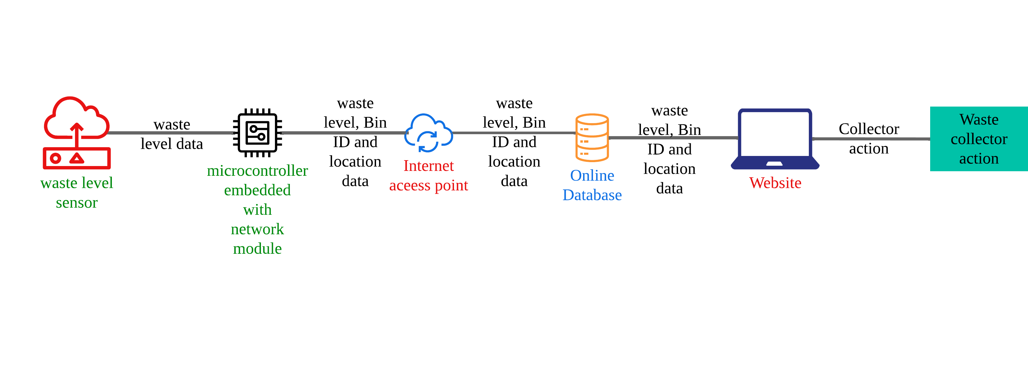

Figure 2.1: Conceptual Framework

# CHAPTER 3: METHODOLOGY

## 3.1: Introduction

This chapter covered the methods used to fulfil the project and state the required outcomes of the project. It also showed in detail how the system is supposed to work.

## 3.2: System Development methodology

The project used prototyping as the preferred software development life cycle methodology. This also meant that the end product of the project was not a finalized product but an expectation of how the system is going to work and can be further tested and evaluated in its life cycle till a final product is achieved.

To break it down further, we implemented incremental prototyping where the project was broken down into smaller bits that were worked on concurrently to create the final product.

Figure .1: Incremental Prototyping model(Martin, 2022)

## 3.3: Project Design Approach

Prototyping is broken down into the following steps: Requirement gathering and analysis, design, building and testing.

### 3.3.1: Requirements gathering and analysis

This entails gathering the necessary requirements (functional and nonfunctional). Requirements were gathered by studying and researching past and related works to come up with more requirements that were missed by previous works.

### 3.3.2: Design

This is the process of coming up with a quick design that was used to guide how the components interacted with each other and what parameters were needed for the system to function. This led to the creation of a system architecture diagram. Tools such as Canva, Creately and Draw.io were used to make the system architecture diagrams.

### 3.3.3 Build, Evaluate, Refine and Implement the Prototype

This step requires us to build the prototype based on the system architecture diagram and send it to users who will give us feedback that will give us the necessary information to make refinements to the prototype. The process does not stop until the user’s requirements are met and once the user’s requirements are met, the product is implemented according to the user’s requirements. This included the creation of back-end code and building the components to create a prototype system. For the code using Arduino, we could run online simulations that would emulate the process.

### 3.3.4: Testing

This step entailed the testing the project implementation to see whether it met the project’s functional and nonfunctional requirements. The product is tested to see whether it did or did not meet the required requirements. This was done by coming up with a table with four columns, one for the functional requirements, the next one for the difficulty, then comments and finally the result if the requirement was achieved or not achieved.

## 3.4: Functional and Nonfunctional requirements

|  |  |
| --- | --- |
| **Functional Requirements** | **Non-functional Requirements** |
| 1. Sensors should be able to detect whether a bin is full. 2. The Wi-Fi module should be able to send data across the internet to an online database, 3. The data should be available from the database and can be accessed from the website and the website should be able to show the location of full bins for collection | 1. The sensors should be up and running 24/7 2. The user should be able to clearly view the parameters from the database |

## 3.5: Tools and techniques

The bins levels were measured using an ultrasonic sensor. The data was sent to an ESP8266 microcontroller that was used to connect to a Wi-Fi network and send the data to Firebase. In firebase, the data was received and then the website used the data from firebase to implement its functionality.

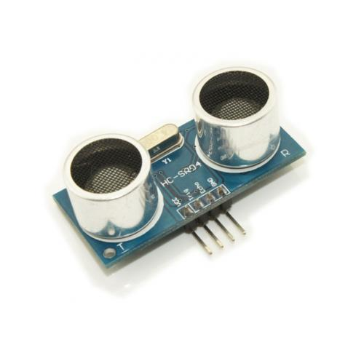

Figure 3.2: Ultrasonic sensor

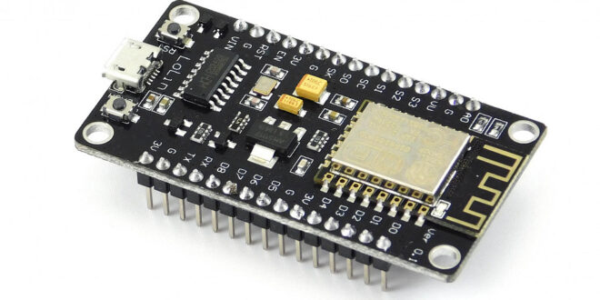

Figure 3.3: ESP8266 Microcontroller

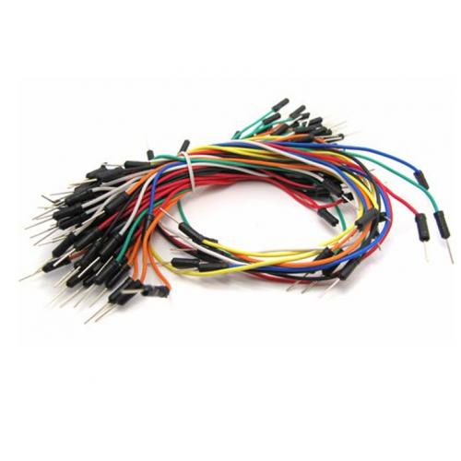

Figure 3.4: Jumper Cables

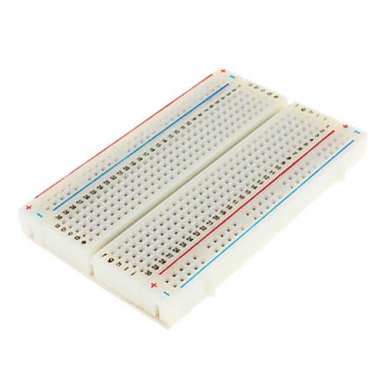

Figure 3.5 Bread Board

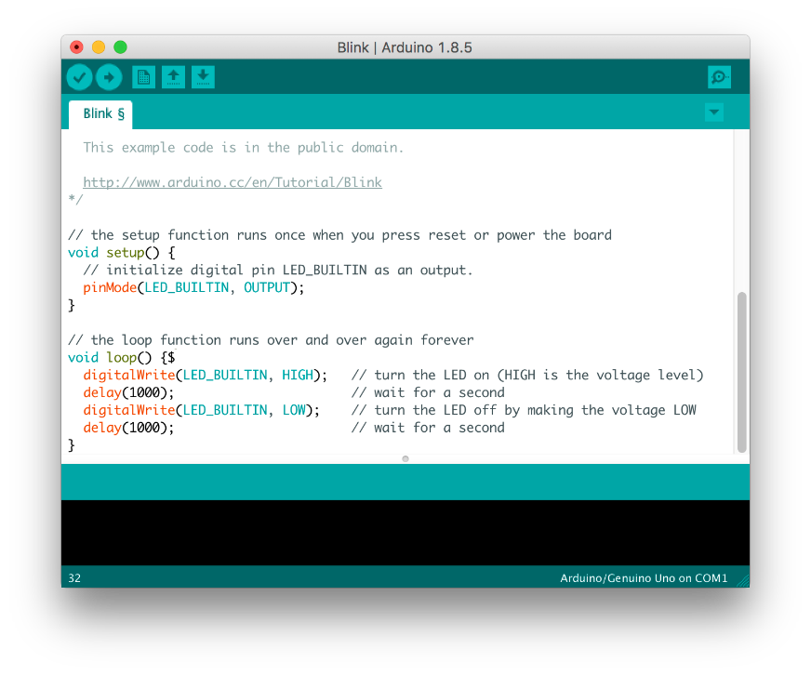

Figure 3.6: Arduino IDE

## 3.6: Deliverables

The project deliverables include creating a system that could detect whether a bin is full or not and creating a user interface that would be used to analyze this information and send out trucks to collect for bins that were full.

# CHAPTER 4: SYSTEM ANALYSIS AND DESIGN

## 4.1: Introduction

This chapter focuses on how the system was implemented on both the system software andhardware side. It incorporates a representation of the general system architecture, flowcharts,and other diagrams that help demonstrate how the efficient prototype works.

## 4.2: System Architecture

The ultrasonic sensor was used to detect the waste levels and the data was sent to the microcontroller. The microcontroller received the waste level data and added bin location data and a unique identification and forwarded it to a Wi-Fi router through a Wi-Fi module. The Wi-Fi module forwarded the data to the internet where it was received in an online database. The online database that stored the data that was sent from the microcontroller and the data was accessed by a website. On the website, the bin data was analyzed to check whether the bin was full or not. The various levels of the bin displayed on the website and when a bin is full an alert would be sent to trucks to collect the bins that were full.

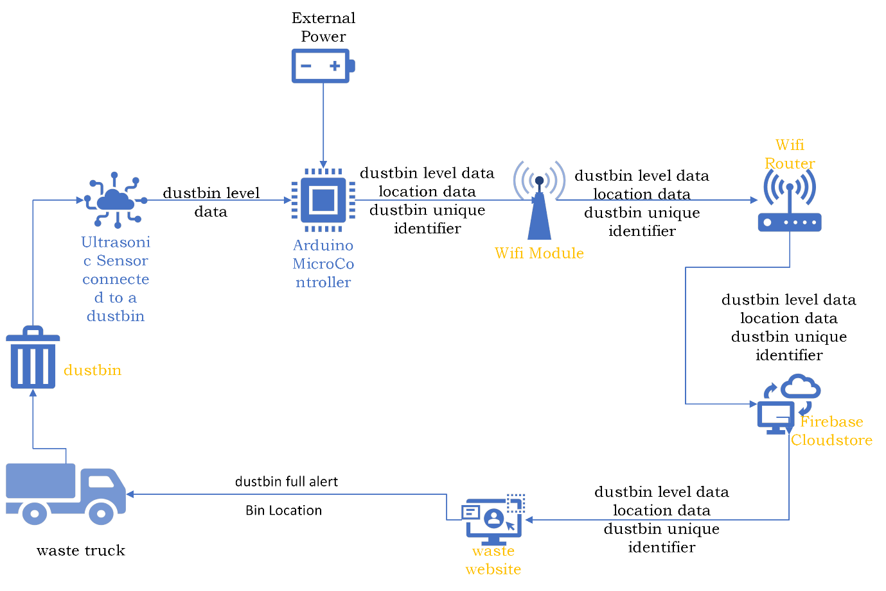

Figure 4.1: System Architecture

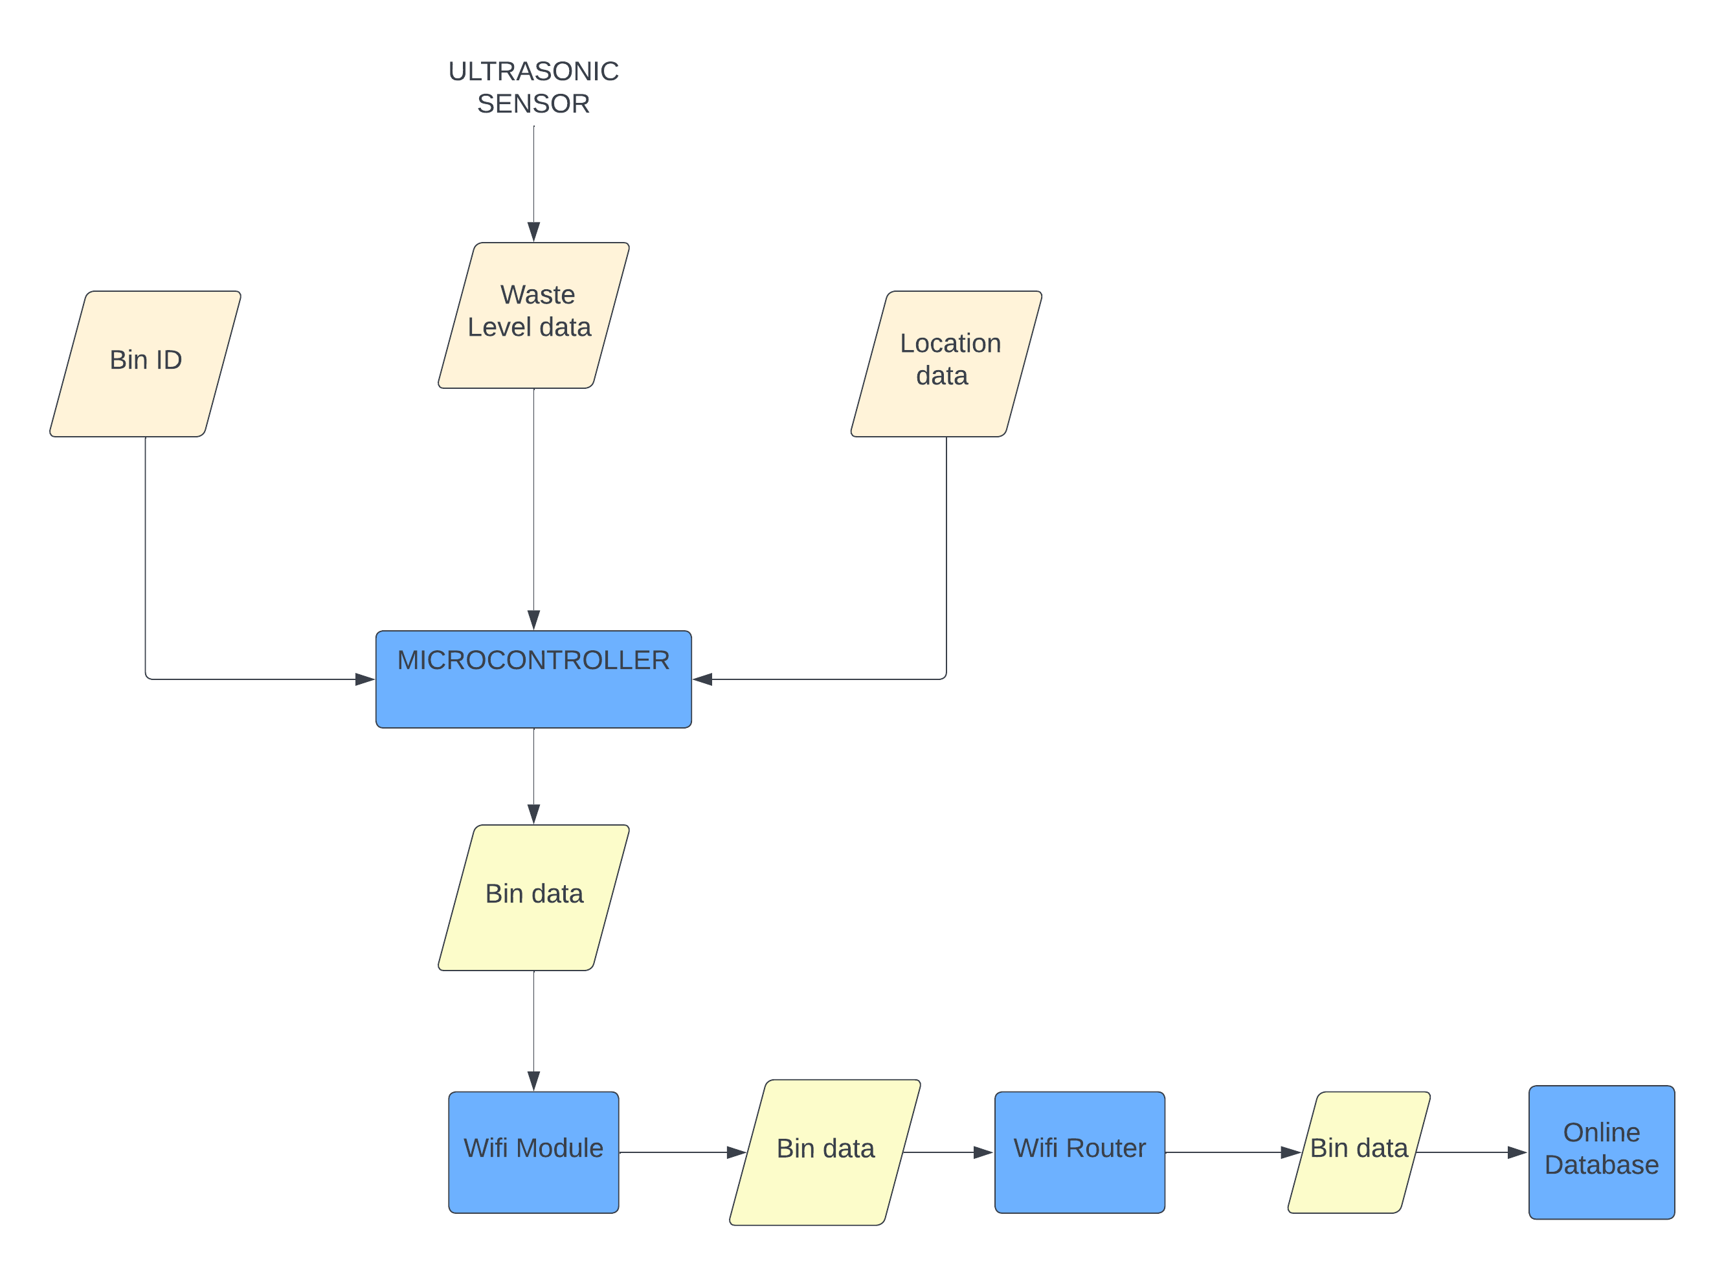

Figure 4.2: System Flow chart Diagram 1

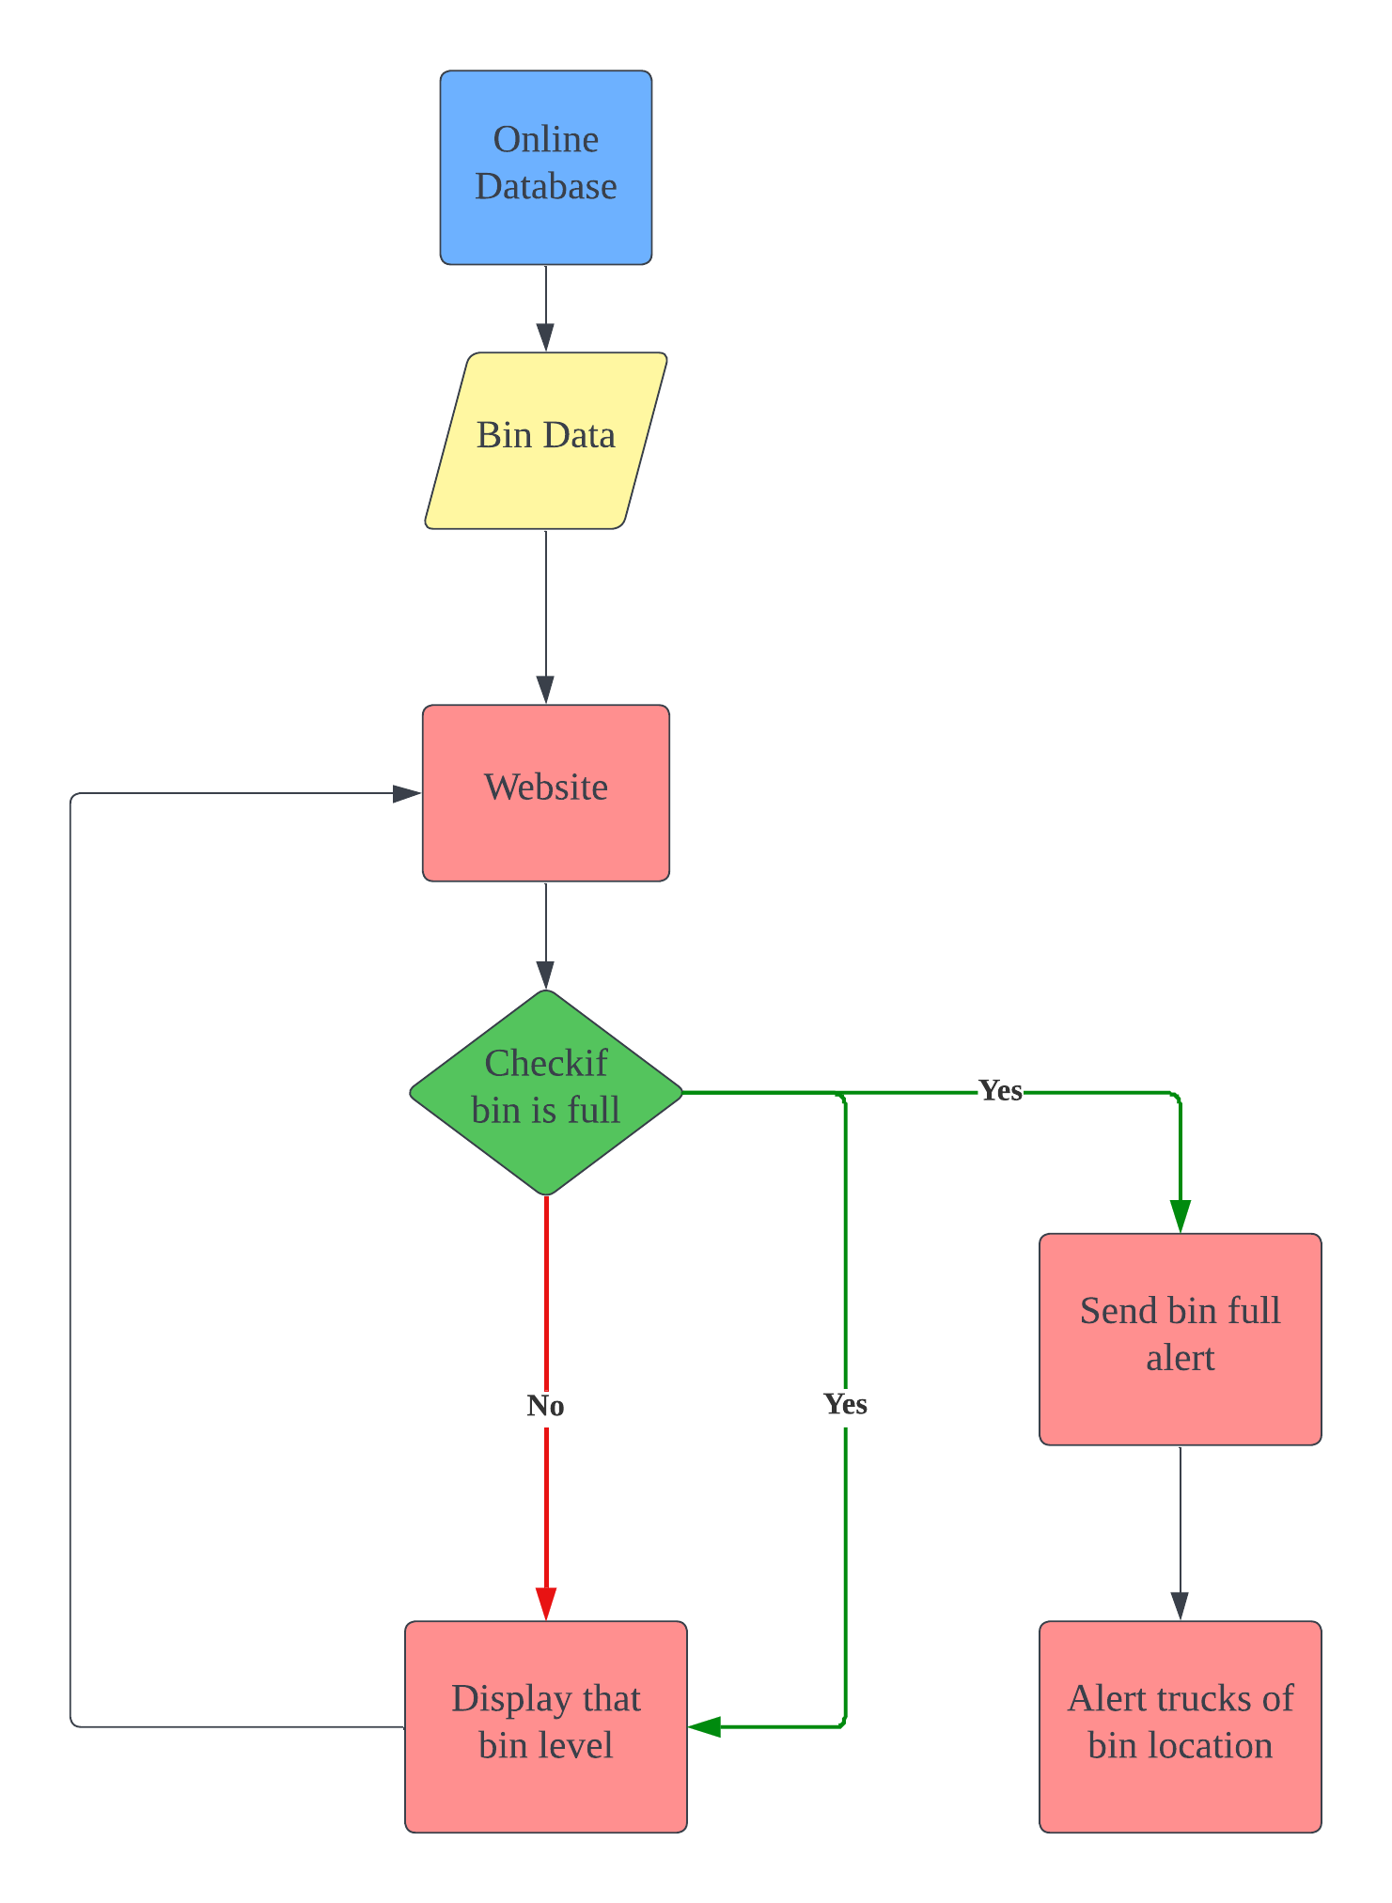

Figure 4.3: System Flow Chart Diagram 2

## 4.3: Software Implementation

### 4.3.1: Arduino IDE

The Arduino IDE version that was version 1.8.19 which can be acquired from the Arduino website. Since I used the NodeMCU board I had to install the necessary board libraries that can be installed by accessing the file>preferences which will lead you to this page below and you copy and the paste the following link on the boards manager url: https://arduino.esp8266.com/stable/package_esp8266com_index.json

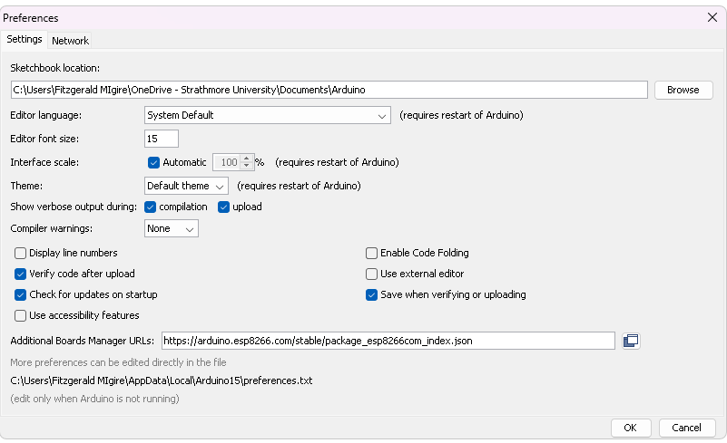

Figure 4.4: ESP8266 setup

Once you copy and paste the link, the boards will be downloaded, and you can install the boards by accessing the board manage and installing the ESP8266 library for boards. I installed the version 2.7.4 as shown below.

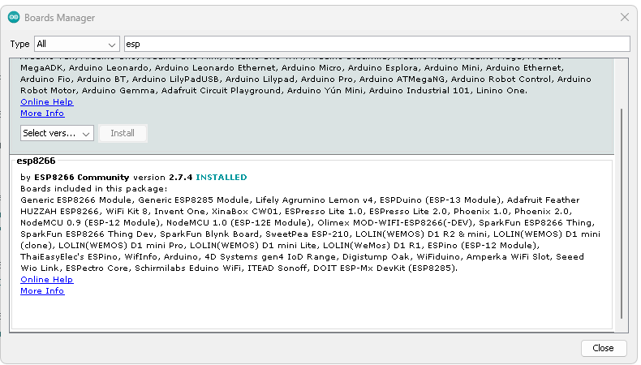

Figure 4.5: ESP8266 Library Setup

Once you install the board, you must install the following libraries that will be used to ensure you can communicate to the board and connect to firebase: Arduino JSON version 5.13.5, ESP8266 Firebase version 1.1.0, Firebase JSON version 3.0.2 and Firebase Arduino Client Library for ESP8266 and ESP32 version 4.2.7.

Once you installed the required libraries, we can write the code used to send sensor data to firebase database. First, we include the require libraries:

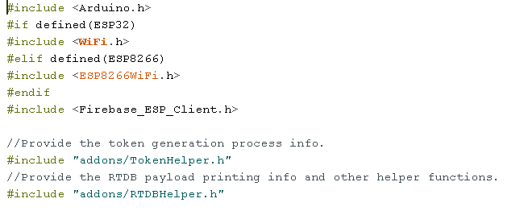

Figure 4.6: Adding required libraries

After we include the libraries, we define the Wi-Fi SSID and password and Firebase API key and database URL.

Figure 4.7: Inclusion of Wi-Fi and firebase credentials

We initialize the firebase objects and the pins used by our ultrasonic sensor.

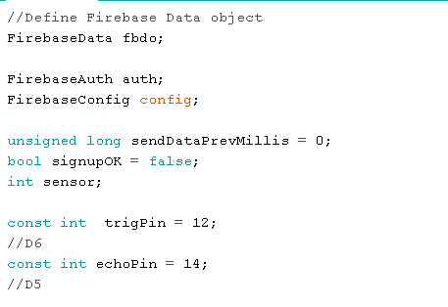

Figure 4.8: Initialization of Firebase objects and pin definition

Afterwards you define, the connection the router and the database were established. And we can also include code that will run incase either of the previously mentioned things does not happen. The board was also set to reconnect incase the signal was lost in any circumstance.

Figure 4.9: Connecting to the Wi-Fi network

Figure 4.10: Connection to firebase

Once a connection was established, the sensor would measure the distance and send the data to firebase. There was also a Bin ID and Location Information that was also sent to firebase. Different paths were defined for the different data sets that were being sent to firebase. There was also code written in case any errors occurred in the sending of data.

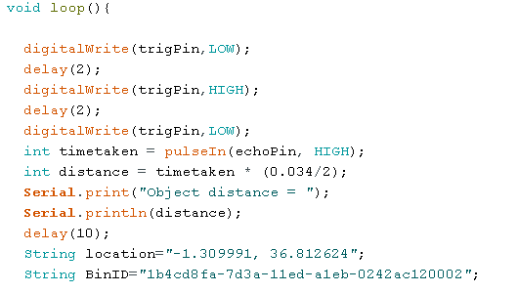

Figure 4.11: Measuring of bin levels

Figure 4.12: Sending bin level data to firebase

Figure 4.13: Sending location data to firebase

Figure 4.14: Sending bin ID to Firebase

### 4.3.2: Firebase

Firebase is a NOSQL database provided by Google that was used to store our data and host our website. Once, I created the project and named it. I accessed the database and made the following changes to its read and write rules. I changed the values to both be true so that I could indefinitely read and write data on the real time database:

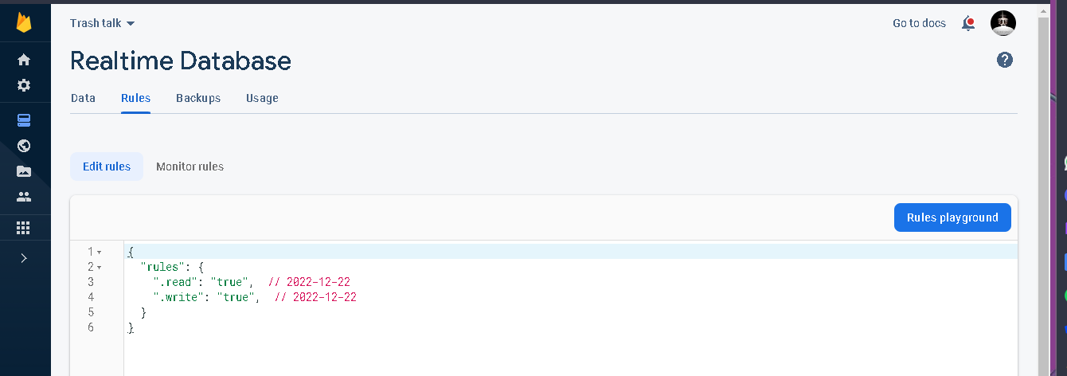

Figure 4.15: Real time database rules

In addition to that, I also went to the authentication part of the firebase console and allowed for anonymous login access to allow me to send data from the NodeMCU board.

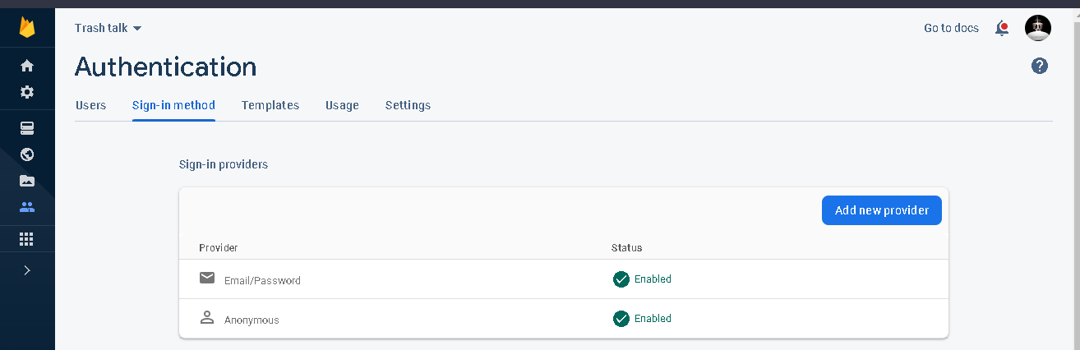

Figure 4.16: Firebase authentication

The paths defined in the Arduino code were created once the board was able to successfully connect and send data to the firebase real time database.

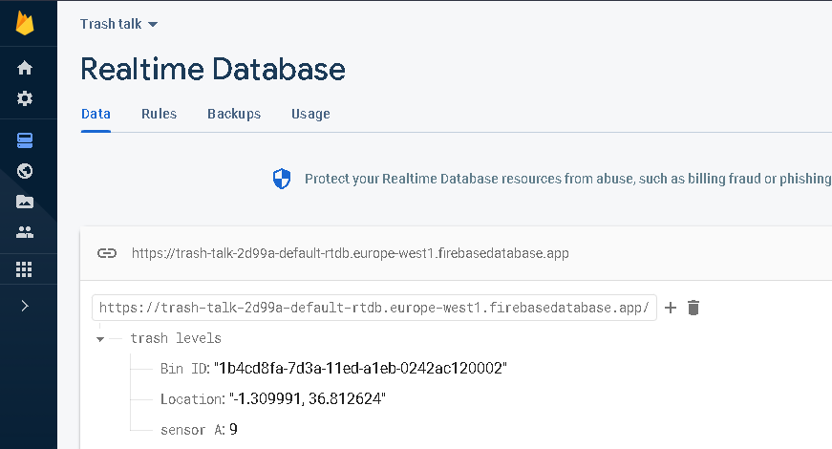

Figure 4.17: Realtime database data and paths

### 4.3.3: Website

A combination of HTML, CSS and JavaScript was used to make the website that was used to monitor the bins. The IDE that was used to write the code was Visual studio which also provided me the tools required to remotely deploy my website to firebase. The landing page showed the bin information and an action button for the bins once the bin is full.

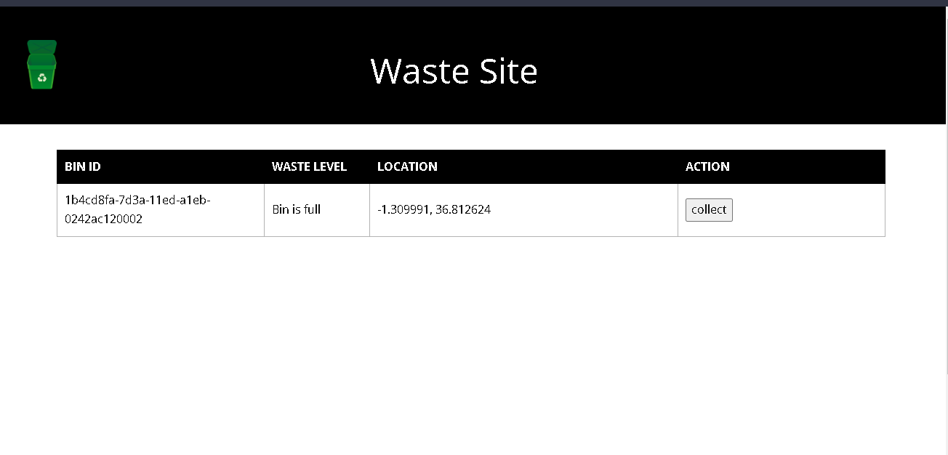

Figure 4.18: Website landing page

Once the bin was full, it led to a page that showed the location and the Bin ID which will be shown in more detail n chapter 5. The following JavaScript code was used to extract the data from firebase to the website.

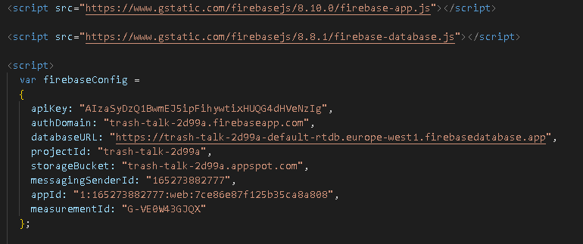

Figure 4.19: JavaScript Firebase connection

## 4.4.: Hardware Implementation

### 4.4.1: Dustbin Prototype

I used an ultrasonic sensor in conjunction with a Node MCU board which acted as both my microcontroller and Wi-Fi module. The images below show the connection between the NodeMCU and the ultrasonic sensor.

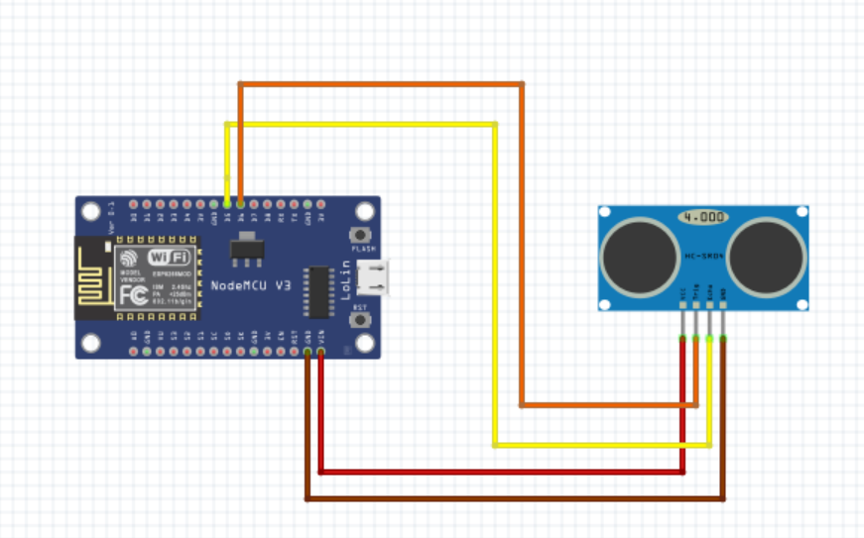

Figure 4.20: Schematic diagram

The table below shows how we mapped the ultrasonic pins to the Node MCU board.

|  |  |
| --- | --- |
| **HC-SR04 ULTRASONIC SENSOR PINOUT** | **NODEMCU PINOUT** |
| VCC | VIN |
| GND | GND |
| Echo | D5 |
| Trigger | D6 |

The setup was then taped to a mockup dustbin that is shown below.

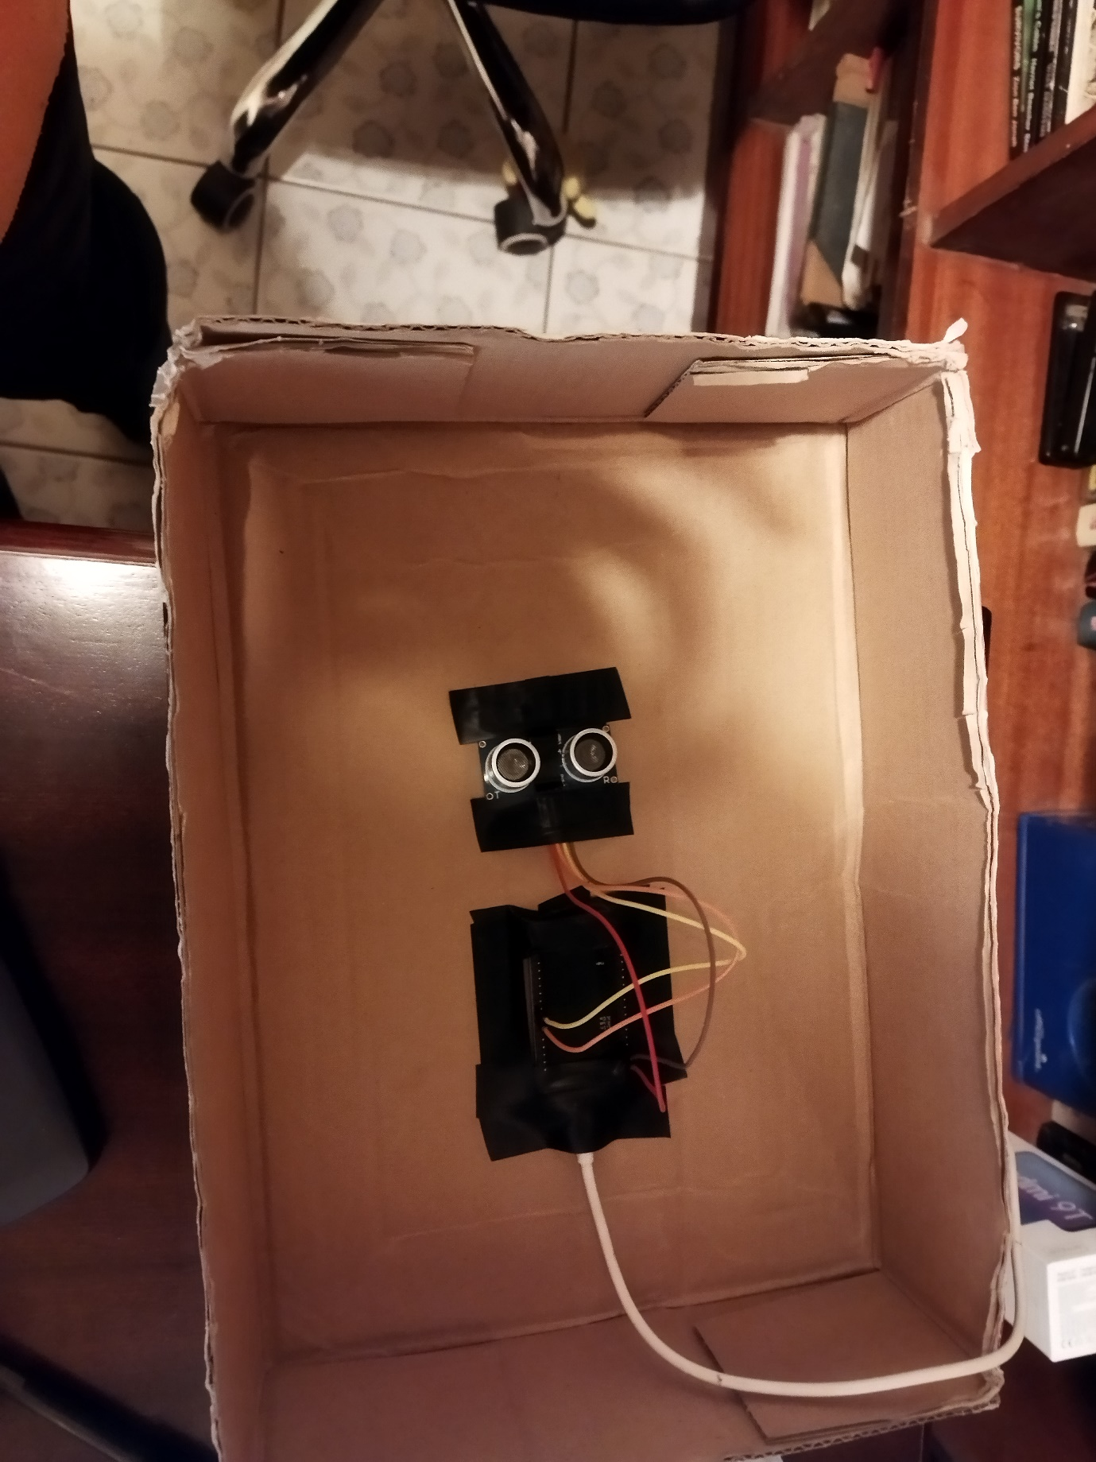

Figure 4.21: Prototype connection to the top of the mock dustbin

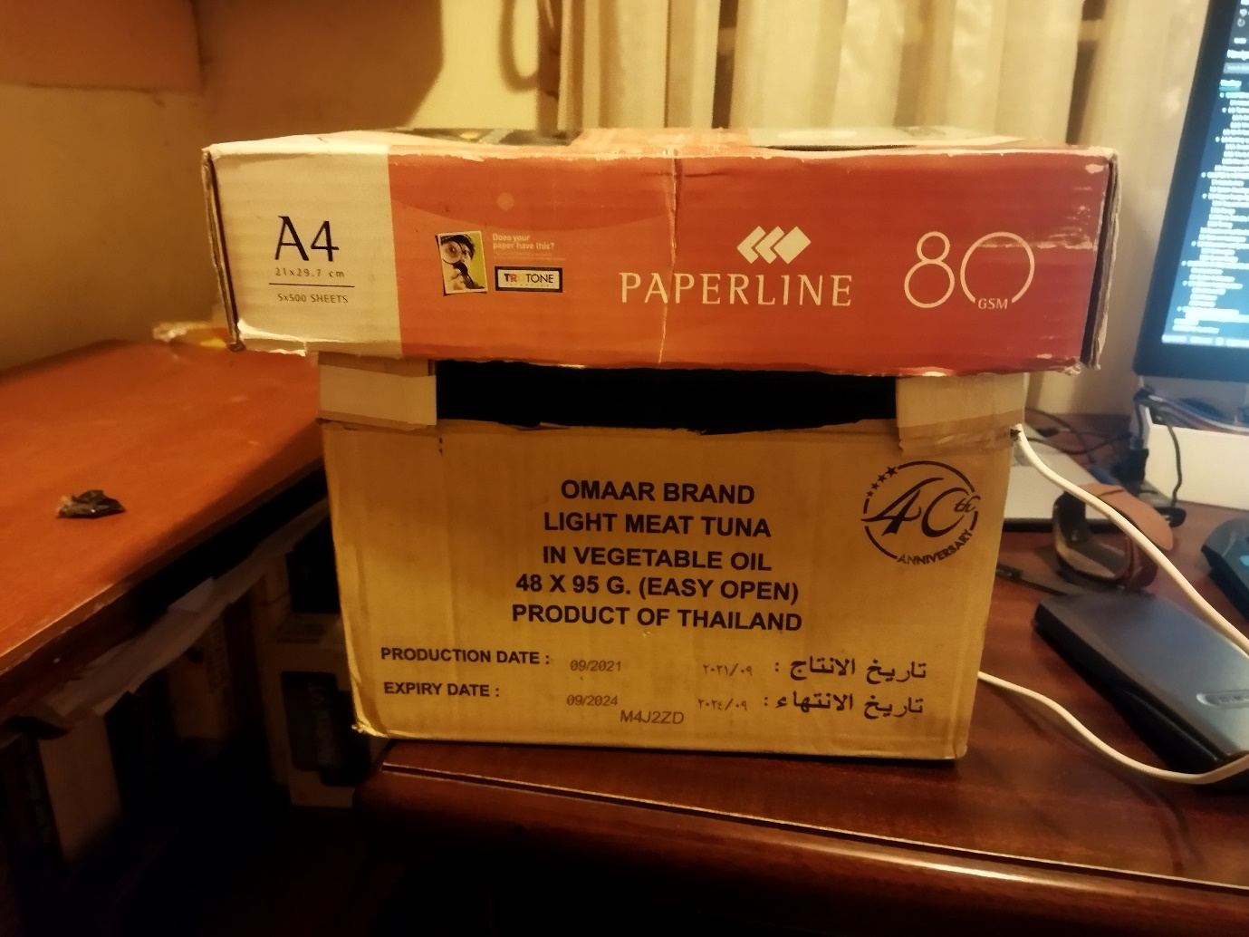

Figure 4.22: Mock dustbin

# CHAPTER 5: TESTING, RESULTS AND DISCUSSION

## 5.1: Introduction

This chapter is an evaluation of results obtained from the prototype. The results are displayed on Arduino’s serial monitor and the web application.

## 5.2: Testing

### 5.2.1: NodeMCU connection

The dustbin was connected to the power and had to establish the connection to the internet by using a router. My phone was used as a hotspot and the router. Once the connection was established the IP address was printed out in the serial monitor. The bin height was measured using the ultrasonic sensor and sent to firebase and the path used in the database was also printed out together with the measurements obtained from the ultrasonic sensor. The bin location and the Bin Id was also sent, and the path was also printed out in the serial monitor.

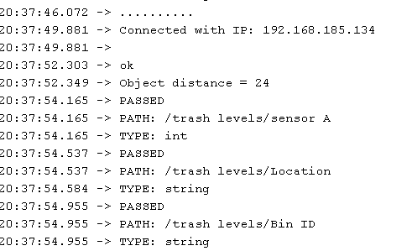

Figure 5.1: Connection to Wi-Fi and data sending.

### 5.2.2: Firebase and Website functionality

Once the data was received, it was displayed in the firebase database and the data was then extracted to the website. I used two types of events to simulate the functionality of the bin.

#### 5.2.2.1: Empty dustbin event

When the dustbin was empty, the height measured in the bin on the database was 24 cm.

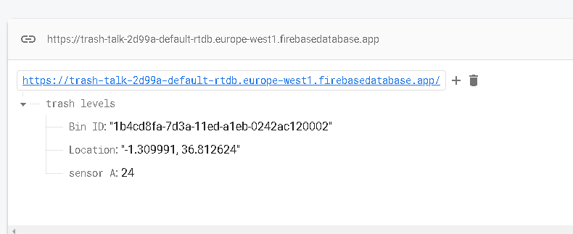

Figure 5.2: Empty dustbin database levels

This was shown on the website that the bin was empty and therefore not ready for collection. Also, shown below is the Bin ID and location that was sent from the microcontroller side.

Figure 5.3: Empty Dustbin monitoring on website

As the bin fills, the website will reflect the various levels of fullness, When the bin is below the halfway point, the bin waste level will reflect that the bin is not full. The bin level at the midpoint will reflect that the bin is half full and above it, it will reflect that the bin is almost full. This information can be used by collectors to know which bins are almost full and also helps in tracking down the time it takes to fill the bin and make proper decisions regarding the bins.

Figure 5.4: Dustbin level below midpoint output on website

Figure 5.5: Dustbin level at midpoint output on website

Figure 5.6: Dustbin level above midpoint output on website

#### 5.2.2.2: Full dustbin event

When the dustbin was full, the measured height of the bin could be a value between 0 to 10 cm, and this was shown in the database.

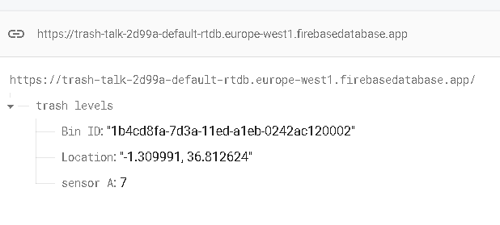

Figure 5.7: Full dustbin database levels

The bin would also show that it was full and be displayed on the website.

Figure 5.8: Dustbin level when full output on website

When the collect action button was pressed, it led to page that showed the Bin Id and a google maps location of the bin. The mock bin location was set to show just inside Strathmore University

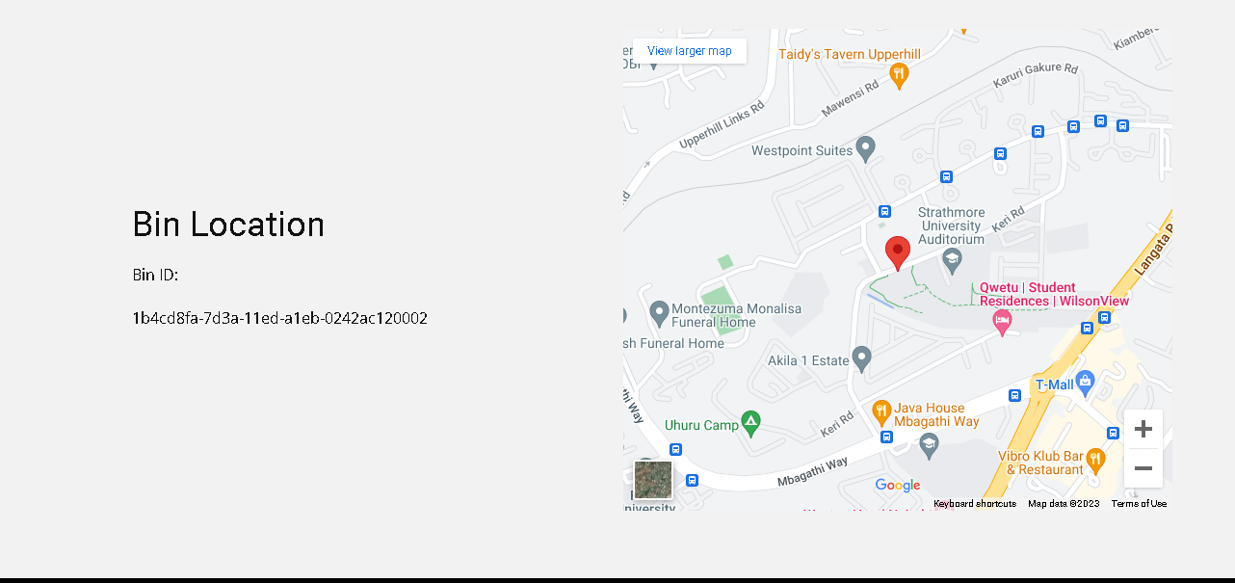

Figure 5.9: Alert when dustbin is full with the location details.

## 5.3: Test Cases

|  |  |  |  |
| --- | --- | --- | --- |
| **Test** | **Steps** | **Expected result** | **Test result** |
| Power the NodeMCU | Connect the NodeMCU to the power via a USB cable | The LED on the NodeMCU blinks showing that it powered on | The LED blinked and showed that the NodeMCU was powered |
| Connect to the Wi-Fi access point | The NodeMCU searched for the parameters defined for the access point defined in the code uploaded to it and uses that to connect to the internet | The serial monitor would show dots to show that it is connecting and when connected it would print out the IP address it was assigned | The serial monitor showed that the NodeMCU was connected to the access point with the IP address: 192.168.185.134 |
| Measure the bin level distance and send the data to firebase | The ultrasonic sensor measures the distance from top to the bottom of the bin and send the data to firebase | The distance of the bin would be shown in centimeters in the serial monitor and the path to the database would be printed to show the path of the data being sent | The distance was printed in the serial monitor and the path for the bin level data was printed out in the serial monitor as:/trash levels/sensor A |
| Send bin ID and location data to firebase | The location and bin identification were hard coded and sent to firebase from the NodeMCU | The paths to the where the data was stored was shown in the serial monitor to show that the data was sent | The serial monitor printed the path locations. They were:/trash levels/Location and /trash levels/Bin ID |
| Bin data could be accessed from firebase | The bin levels, bin ID and location could be viewed from firebase. | The data could be seen in the firebase real time database with the paths defined | Firebase displayed the bin id as 1b4cd8fa-7d3a-11ed-a1eb-0242ac120002 and the bin location as -1.309991, 36.812624 and the bin level was dependent on the measurement of the ultrasonic sensor |
| Displaying data from the website | The data was extracted from firebase and different outputs were shown for different bin levels | The website showed the bin ID, location, and level. The level would display depending on the level the trash had achieved in the bin | The website displayed the bin data. The information displayed on the bin level differed when the bin was empty, halfway full, below the midpoint and above the midpoint |
| Sending alerts when the bin was full | Once the bin exceeded a certain threshold, it would allow users to trigger a full bin event that would send out an alert | The bin level would display that the bin is full and would allow the users to send an alert that showed the location and the bin ID | When bin levels were full, an alert was sent that showed the location as Strathmore university and showed the bin ID as 1b4cd8fa-7d3a-11ed-a1eb-0242ac120002 |

## 5.4: Conclusion

The system satisfies the objectives that were set and followed the conceptual framework in chapter 2. The system testing showed that the bin levels were able to be determined and the data was able to be sent to a central database where it can be stored. The data was also able to be viewed on a graphical user interface that was in the form of a website where one could check if the bins were full or not and once a bin was full. An alert was able to be sent and show the location of the bin and direct the collectors to the point of collection.

# CHAPTER 6: CONCLUSION AND RECOMMENDATIONS

## 6.1: Conclusion

The prototype developed is just the first step to a cleaner city. The prototype was able to help in identifying if a bin was full or not and sent data very timely without any delay and created an interface that allowed for remote monitoring of the bins. The prototype should do much better than the current system of waste collection that is in Nairobi city county since it allows for monitoring of different bins across the city and allowing for prompt collection of the litter dropped at various bins in the city. The prototype underwent many iterations and some components had to be changed to allow for a working prototype such as changing from infrared to an ultrasonic sensor. The results from chapter 5 show that the prototype can be implemented in cities with some minor improvements to the overall system.

## 6.2: Recommendations

The project used Wi-Fi as its access network. The project could however be improved by use of low power wide area networks such as LoRa WAN that could reduce the cost of having the bins fitted with their own access points. LoRa WAN uses less power compared to Wi-Fi and the modules for use are available. The project also just used one sensor to detect the bin levels of the bin However, to ensure that there is more accuracy, more sensors can be used to measure the bin levels and introduce a level of redundancy. The bins could also be fitted with sensors that could determine whether the waste is dry or wet to help prepare the collection.

## 6.3: Future Works

In the future, the proposed system could not only be used in cities but also other similar settings such as gated communities and offices. The system could also be implemented with other technologies used in waste management like AI run bins that sort waste automatically that could also help in easy waste collection. The project would work with small scale cleaning services that help in catering for large cooperations and help with their internal waste management. The bins could also be fitted with actuators that close the bins when full and a way to alert the people that the bins are full and that they should dump their litter in the next available bin.

# REFERENCES

*Cleaning Nairobi City | Nairobi City County*. (2019, June 6). https://nairobi.go.ke/cleaning-nairobi-city-2/

Cruz, N., Cota, N., & Tremoceiro, J. (2021). LoRaWAN and Urban Waste Management—A Trial. *Sensors*, *21*(6), 2142. https://doi.org/10.3390/s21062142

Frankenfield, J. (2022, July 6). *Artificial Intelligence: What It Is and How It Is Used*. Investopedia. https://www.investopedia.com/terms/a/artificial-intelligence-ai.asp

Gast, M. (2005). *802.11 wireless networks: The definitive guide* (2nd ed). O’Reilly.

Kaushik, V. (2021, August). *Australia adopts new waste management strategy via Nokia AI Tech | Analytics Steps*. https://www.analyticssteps.com/news/australia-adopts-new-waste-management-strategy-nokia-ai-tech

Martin, M. (2022, November 19). *Prototype Model in Software Engineering*. Prototype Model in Software Engineering. https://www.guru99.com/software-engineering-prototyping-model.html

Muniafu, M., & Otiato, E. (2010). Solid Waste Management in Nairobi, Kenya. A case for emerging economies. *Journal of Language, Technology & Entrepreneurship in Africa*, *2*(1), 342–350. https://doi.org/10.4314/jolte.v2i1.52009

Vethaak, A. D., & Leslie, H. A. (2016). Plastic Debris Is a Human Health Issue. *Environmental Science & Technology*, *50*(13), 6825–6826. https://doi.org/10.1021/acs.est.6b02569

Vidyasagar, P., Sharif, A., & Chang, E. (2009, May). Wireless Sensor Networks: A Survey. *2009 International Conference on Advanced Information Networking and Applications Workshops*. 2009 IEEE 23rd International Conference on Advanced Information Networking and Applications Workshops (WAINA), Bradford, UK.

# APPENDIX A: Gantt Chart

